H.T No
Regulations:
A18

Sreenidhi Institute of Science and Technology
(An Autonomous Institution)
Code No: 7B621 Date: 09-Sept-2021 (FN)

B.Tech III-Year II- Semester External Examination, Aug/Sept - 2021 (Regular)
CAD/CAM and FEA (ME)

Time: 3 Hours Max.Marks:70

Note: a) No additional answer sheets will be provided.
b) All sub-parts of a question must be answered at one place only, otherwise it will not be valued.
c) Missing data can be assumed suitably.

ANSWER ANY 5 OUT OF 8 QUESTIONS. EACH QUESTION CARRIES 14 MARKS.

Bloom's Cognitive Levels of Learning (BCLL)

Remember | L1 | Apply | L3 | Evaluate | L5
Understand | L2 | Analyze | L4 | Create | L6

 |  |  | BCLL | CO(s) | Marks
1. | a) | Derive parametric form of equation for Bezier Curve. | L4 | CO1 | [7M]
 | b) | Explain various Surface entities in detail in surface modeling. | L2 | CO1 | [7M]
2. | a) | Explain various graphics Terminals used in CAD. | L2 | CO2 | [7M]
 | b) | What are the different line drawing algorithms? | L2 | CO2 | [7M]
3. | a) | Generate the NC Part program for the given fig .1  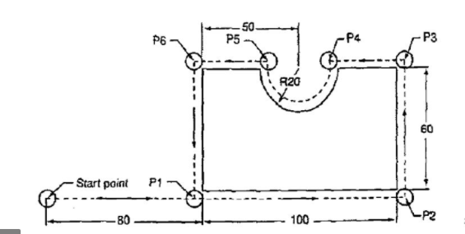  Fig 1 | L5 | CO3 | [7M]
 | b) | Explain various inspection methods used in CAQC. | L4 | CO3 | [7M]
4. | a) | Explain the Steps involved in FEM for solving any one dimensional element. | L3 | CO4 | [7M]
 | b) | Derive the shape functions for a one dimensional linear line element in global Co-ordinate system. | L5 | CO4 | [7M]
5. | a) | Compare the characteristics of beam element with the truss element. | L6 | CO5 | [7M]
 | b) | List various properties of stiffness matrix used in FEA. | L3 | CO5 | [7M]
6. | a) | List of the limitations of regular FEA Softwares. | L4 | CO6 | [7M]
 | b) | Explain the two major methods of mesh refinement. | L2 | CO6 | [7M]
7. | a) | What is major difference between topology and geometry in Geometric modeling. | L3 | CO1 | [5M]
 | b) | List various 2D transformations in computer graphics. | L2 | CO2 | [5M]
 | c) | What is part family concept? | L1 | CO3 | [4M]
8. | a) | Explain the natural and geometric boundary conditions. | L4 | CO4 | [5M]
 | b) | Write short notes on Convergence requirements. | L4 | CO5 | [5M]
 | c) | Explain briefly about Mesh preparation for tetrahedral element. | L4 | CO6 | [4M]
-- 00 -- 00 –

